Day 1 & 2 – Solving One & Two Step Equations
Standard(s)
MFAEI1. Students will create and solve equations and inequalities in one variable.
MFAEI1.a. Use variables to represent an unknown number in a specified set (conceptual understanding of a variable). (MGSE6.EE.2, 5, 6)

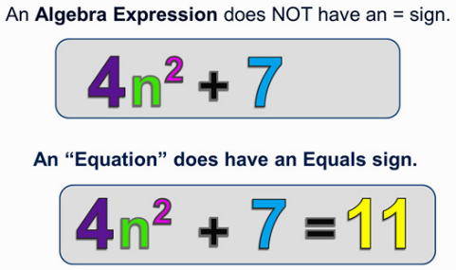
Remember, an expression is a mathematical “phrase” composed of terms, coefficients, and variables that stands for a single number, such as 3x + 1 or x² – 1. We use Properties of Operations to simplify algebraic expressions. Expressions do NOT contain equal signs.

An equation is a mathematical “sentence” that says two expressions are equal to each other such as 3x + 1 = 5. We use Properties of Equality (inverse operations) to solve algebraic equations. Equations contain equal signs.

When solving equations, you must perform inverse operations, which means you have to perform the operation opposite of what you see. You must also remember the operation you perform on one side of the equation must be performed to the other side.

Informal |  | Formal
Operation | Inverse | Property | General Example | Example 1
Addition |  | Addition Property of Equality | If a = b,  then a + c = b + c | If x – 4 = 8, then x = 12
Subtraction |  | Subtraction Property of Equality | If a = b,  then a – c = b - c | If x + 5 = 7, then x = 2
Multiplication |  | Multiplication Property of Equality | If a = b,  then ac = bc | If $\frac{x}{2}=9$, then x = 18
Division |  | Division Property of Equality | If a = b,  then $\frac{a}{c}= \frac{b}{c}$ | If 2x = 10, then x = 5

No More “Cancelling”

When you first learned to solve equations in middle school, you might have used the words “cancel”. We are no longer going to use the word “cancel”. Look at the following examples:
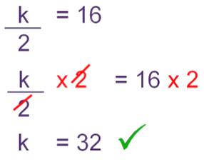
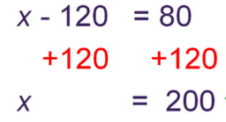

Adding the opposite
Additive inverse Multiplying by the Reciprocal
Adding to zero Multiplicative Inverse
Divides/Multiplies to one

Additive Inverse | A number plus its inverse equals 0. | a + -a = 0 | 7 + -7 = 0
Multiplicative Inverse  (Reciprocal) | A number times its reciprocal equals 1. | a ∙ $\frac{1}{a}$= 1 | 3 ∙ $\frac{1}{3}$= 1

Solving One Step Equations Practice

Practice: Solve each equation.

1. x – 4 = 3 Operation You See: _______________ Inverse Operation: _______________

2. y + 4 = 3 Operation You See: _______________ Inverse Operation: _______________

3. Operation You See: _______________ Inverse Operation: _______________

4. 6p = 12 Operation You See: _______________ Inverse Operation: _______________

Practice: Solve each equation on your own.
a. x – 6 = 10 b. -5d = 25 c. 8 + m = -4

d. e. y – (-9) = 2 f. $\frac{1}{3}x=6$

