Name: ______________________ Block: __________ Teacher: _______________

Foundations of Algebra

Module 2 Notes:

Arithmetic to Algebra

**DISCLAIMER:** We will be using this note packet for Module 2. You will be responsible for bringing this packet to class EVERYDAY. If you lose it, you will have to print another one yourself.

|  |  |  |
| --- | --- | --- |
| **Standard** | **Sub-Standard** | **Lesson** |
| **MFAAA1.** Students will generate and interpret equivalent numeric and algebraic expressions. | a. Apply properties of operations emphasizing when the commutative property applies. **(MGSE7.EE.1)** |  |
| b. Use area models to represent the distributive property and develop understandings of addition and multiplication (all positive rational numbers should be included in the models). **(MGSE3.MD.7)** |  |
| c. Model numerical expressions (arrays) leading to the modeling of algebraic expressions. **(MGSE7.EE.1,2; MGSE9-12.A.SSE.1,3)** |  |
| d. Add, subtract, and multiply algebraic expressions. **(MGSE6.EE.3, MGSE6.EE.4, MC7.EE.1, MGSE9-12.A.SSE.3)** |  |
| e. Generate equivalent expressions using properties of operations and understand various representations within context. For example, distinguish multiplicative comparison from additive comparison. Students should be able to explain the difference between “3 more” and “3 times”. **(MGSE4.0A.2; MGSE6.EE.3, MGSE7.EE.1, 2, MGSE9-12.A.SSE.3)** |  |
| f. Evaluate formulas at specific values for variables. For example, use formulas such as A = l x w and find the area given the values for the length and width. **(MGSE6.EE.2)** |  |
| **MFAAA2.** Students will interpret and use the properties of exponents. | a. Substitute numeric values into formulas containing exponents, interpreting units consistently. **(MGSE6.EE.2, MGSE9-12.N.Q.1, MGSE9-12.A.SSE.1, MGSE9-12.N.RN.2)** |  |
| b. Use properties of integer exponents to find equivalent numerical expressions. **(MGSE8.EE.1)** |  |
| c. Evaluate square roots of perfect squares and cube roots of perfect cubes **(MGSE8.EE.2)** |  |
| d. Use square root and cube root symbols to represent solutions to equations of the form 𝑥2 = 𝑝 and 𝑥3 = 𝑝, where p is a positive rational number. **(MGSE8.EE.2)** |
| e. Use the Pythagorean Theorem to solve triangles based on real-world contexts (Limit to finding the hypotenuse given two legs). **(MGSE8.G.7)** |

**Module 2: Arithmetic to Algebra**

After completion of this unit, you will be able to…

**Learning Target #1: Algebraic Expressions**

* Simplify an algebraic expression
* Create an expression from a verbal description
* Identify parts of an expression as variables, coefficients, or constants
* Interpret parts of an Expression in terms of a context

**Learning Target #2: Laws of Integer Exponents**

* Multiplying powers
* Power to a power
* Product to a power
* Dividing powers
* Raising a quotient to a power
* Negative and Zero Powers

**Learning Target #3: Pythagorean Theorem**

* Finding missing sides of a right triangle
* Real world application of Pythagorean Theorem

**Day 1 – Algebraic Expressions**

**Standard(s):** **MFAAA1.** Students will generate and interpret equivalent numeric and algebraic expressions.

c. Model numerical expressions (arrays) leading to the modeling of algebraic expressions. **(MGSE7.EE.1,2; MGSE9-12.A.SSE.1,3)**

An expression containing variables (letters), numbers, and operation symbols is called an

______________________ ________________________. An expression does NOT contain an equal sign.

An example of an algebraic expression is 5x + 7y – 3.

In an algebraic expression, there are four different parts: coefficients, variables, constants, and terms.

**5x + 7y - 3**

**Variables** are the letters in an expression. **Coefficients** are the numbers in front of the variables.

**Constants** are the “plain numbers” or terms **Terms** are separated by a + or – sign and can be numbers

without variables. and/or variables.

**Factors** of each term are the numbers or expressions that when multiplied produce a given product.

Practice: Complete the table below.

|  |  |  |  |  |  |
| --- | --- | --- | --- | --- | --- |
| **Expression** | **List Terms** | **List Factors** | **List Coefficients** | **List Variables** | **List Constants** |
| 2x + 5z - 3 |  |  |  |  |  |
| 13 |  |  |  |  |  |
| 6m3 – 9m2 + s – 4 |  |  |  |  |  |
| x2 + 7x -1 |  |  |  |  |  |

**Combining Like Terms**

Terms with the same variable raised to the same exponent are **like terms.**

|  |  |  |
| --- | --- | --- |
| **Like**: 3x and -7x | **Like**: 2y2 and 6y2 | **Not Like:** 4x and 6x2  Why??? |

**Directions:** Simplify the following expressions:

1. -3x + 6x 2. y – 3 + 6 – 2y 3. 

4. 8m + 1n – 3 + 10 5. 9x – 10x2 + 7x – 3 6. 

**Distributive Property**

**Distributive Property states….**

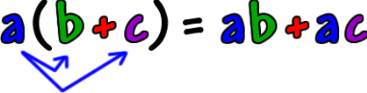

1. 5(x + 2) 2. -3(x – 4) 3. -6(-2x – 3)

4. 4x - 5(x – 1) 5. -2(4 + x) + 4(2 – 8x) + 5 6. 2(3 + x) + x(1 – 4x) + 5

**Connect:** Take the simplified expression from number 6 and answer the following questions:

a. Identify all the terms: ____________________________________________________________________

b. Identify all the factors: ___________________________________________________________________

c. Identify all the coefficients: _______________ d. Identify all the constants: _____________

**Evaluating Expressions**

When you **evaluate** an expression, you are replacing the variable with what the variable equals:

**Evaluate** 4x – 5 when x = 6

Practice: Evaluate the following expressions if m = 7, r = 8, and t = -2.

a. 5m – 6 b.  c. 3m – 5t d. t2 – 4r

Application: Answer the following questions:

1. You earn 15n dollars for mowing n lawns.

a. How much do you earn for mowing 1 lawn?

b. How much do you earn for mowing 9 lawns?

2. After m months, the length of a fingernail is 10 + 3m millimeters.

a. How long is the fingernail, in centimeters, after 8 months?

b. How long is the fingernail after three years?

**Day 2 – Creating Algebraic Expressions**

**Standard(s):** **MFAAA1**. **e.** Generate equivalent expressions using properties of operations and understand various representations within context. For example, distinguish multiplicative comparison from additive comparison. Students should be able to explain the difference between “3 more” and “3 times”. **(MGSE4.0A.2; MGSE6.EE.3, MGSE7.EE.1, 2, MGSE9-12.A.SSE.3)**

**Review: The Commutative and Associative Properties**

|  |  |
| --- | --- |
| *Commutative Property of Addition*  (order doesn’t matter)  5 + 6 can be written as 6 + 5  *Commutative Property of Multiplication*  (order doesn’t matter)  5 x 6 can be written as 6 x 5 | *Associative Property of Addition*  (grouping order doesn’t matter)  2 + (5 + 6) can be written as (2 + 6) + 5  *Associative Property of Multiplication*  (grouping order doesn’t matter)  (2 x 5) x 6 can be written as 2 x (6 x 5) |

|  |  |  |  |  |
| --- | --- | --- | --- | --- |
| **Addition** | **Subtraction** | **Multiplication** | **Division** | **Exponents** |
| Sum | Difference | Of | Quotient | Power |
| Increased by | Decreased by | Product | Ratio of | Squared |
| More than | Minus | Times | Each | Cubed |
| Combined | Less | Multiplied by | Fraction of |  |
| Together | Less than | Double, Triple | Out of |  |
| Total of | Fewer than | Twice | Per |  |
| Added to | How many more | As much | Divided by |  |
| Gained | Left | Each | Split |  |
| Raised | **Use Parenthesis:** The quantity of | | | |
| Plus |

**Subtraction** and **Division** can be very tricky because order DOES matter unlike **Addition** and **Multiplication.** Take a look at the following verbal descriptions:

|  |  |  |  |
| --- | --- | --- | --- |
| **Addition**  The sum of x and 4. | **Multiplication**  The product of x and 3. | **Subtraction**  The difference of x and 5.  x decreased by 5  Five less than x | **Division**  The quotient of x and 7  The ratio of x and 7 |

**Practice:** Write the expression for each verbal description:

1. The difference of a number and 5 2. The quotient of 14 and 7 3. y decreased by 17

4. x increased by 6 5. The sum of a number and 8 6. 6 squared

7. Twice a number 8. 8 more than a third of a number 9. 6 less than twice k

10. Five divided by the sum of a and b. 11. The quotient of k decreased by 4 and 9.

12. 2 minus the quantity 3 more than p 13. Half of the quantity 1 less than w

14. Nine less than the total of a number and 2. 15. The product of a number and 3 decreased by 5

**Practice:** Write each as a verbal expression. You may not use the words add, subtract (minus), times, or divide.

1. 

2. a + 9

3. 5n - 7

4. 3(y + 7)

**Creating Expressions from a Context**

Think About It: At the post office, it costs $5.95 to ship a package that weighs up to five pounds. If Sarah wanted to ship _____ boxes, how much would it cost? (Show your calculations)

a. 3 boxes b. 5 boxes c. 8 boxes d. x boxes

e. In the above problem, what value remained constant? _________________________________________________

f. What did that value represent? _________________________________________________________________________

g. In the above problem, what continued to change? ____________________________________________________

As we begin studying Algebra, one of the most important concepts you will encounter is the use of a symbol, typically a letter, to represent a quantity that varies or changes. The use of letters or symbols is called **variables.** When you perform the same mathematical process over and over, you can use an **algebraic expression** to represent the situation.

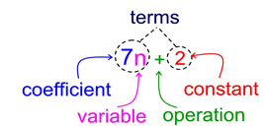

Practice: Use the tables below to create an expression to represent each situation. Then answer the questions on the right.

**Scenario A**: *A school lunch costs $2.10 per student. Determine how much is collected for each number of students. Show your work in the table*

|  |  |
| --- | --- |
| # of students | Cost |
| 52 |  |
| 78 |  |
| 429 |  |
| x |  |

a. What value remains constant?

b. What does that value represent?

c. What continuously changes?

d. What expression represents the situation?

e. What does the variable, x, represent?

**Scenario B:** The cost to rent a skating rink is $215. The cost will be shared equally among all the people who attend the party. Determine how much each person will pay if the following amount of people attend.

|  |  |
| --- | --- |
| # of people | Cost |
| 25 |  |
| 43 |  |
| 81 |  |
| x |  |

a. What value remains constant?

b. What does that value represent?

c. What continuously changes?

d. What expression represents the situation?

e. What does the variable, x, represent?

**Scenario C:** A water tank hold 100 gallons of water. The tank is leaking at a rate of two gallons a minute. Determine how many gallons of water will be left in the tank if it leaks for the following amount of minutes.

|  |  |
| --- | --- |
| # of minutes | # of gallons remaining |
| 1 |  |
| 10 |  |
| 34 |  |
| x |  |

a. What value(s) remains constant?

b. What does that value represent?

c. What continuously changes?

d. What expression represents the situation?

e. What does the variable, x, represent?

**Scenario D:** For competing in the Spelling Bee, I get $3 for each correct word I spell in addition to $50 for participating. Determine how much money I will make for each of the correct words I spell.

|  |  |
| --- | --- |
| # of words | Amount of $ I get |
| 6 |  |
| 18 |  |
| 30 |  |
| X |  |

a. What value(s) remains constant?

b. What does that value represent?

c. What continuously changes?

d. What expression represents the situation?

e. What does the variable, x, represent?

**Day 3 – Creating Algebraic Expressions from a Context**

**Standard(s):** **MFAAA1**. **e.** Generate equivalent expressions using properties of operations and understand various representations within context. For example, distinguish multiplicative comparison from additive comparison. Students should be able to explain the difference between “3 more” and “3 times”. **(MGSE4.0A.2; MGSE6.EE.3, MGSE7.EE.1, 2, MGSE9-12.A.SSE.3)**

Yesterday, you explored creating algebraic expressions from looking at patterns and using tables. Today, you are going to continue to create algebraic expressions, but at a much deeper level.

**Scenario A:** A local restaurant is busiest on Saturday evenings. The restaurant has three cooks who work during this time. The cooks divide the incoming orders among themselves. So far, they have prepared 27 total.

a. If 15 additional orders come in, how many meals will each cook prepare?

b. If 42 additional orders come in, how many meals will each cook prepare?

c. Write an expression to represent the unknown number of meal each cooks prepare. Let m represent the number of additional orders.

**Scenario B:** Trey is selling candy bars to raise money for his basketball team. The team receives $1.25 for each candy bar sold. He has already sold 25 candy bars.

a. If Trey sells 10 more candy bars, how much money will he raise for the basketball team?

b. If Trey sells 45 more candy bars, how much money will he raise for the basketball team?

c. Write an expression to represent the unknown amount of money Trey will raise for the basketball team. Let c represent the additional candy bars sold.

**Scenario C:** Four friends decide to start a summer business of yardwork for their neighborhood. They will split all their earnings evenly. They have lawnmowers, but need to invest some money into rakes, trash bags, rakes, and hedge trimmers. They have to spend $75 on these supplies.

a. How much profit will each friend receive if they earn $350 the first week?

b. How much profit will each friend receive if they earn $475 the first week?

c. Write an expression that represents the unknown profit for each friend. Let d represent the amount of money earned.

**Scenario D:** Rebekah, Daily, Savannah, and Faith each collect DVDs.

Daily says “I have twice as many DVDs as Rebekah.”

Savannah says “I have four more DVDs than Daily.”

Faith says “I have three times as many as Savannah.”

|  |  |  |  |  |
| --- | --- | --- | --- | --- |
| # of DVDs for Rebekah | # of DVDs for Daily | # of DVDs for Savannah | # of DVDs for Faith | Total # of DVDs |
| 2 |  |  |  |  |
| 5 |  |  |  |  |
| 8 |  |  |  |  |
| x |  |  |  |  |

**Scenario E:** Five friends (Jack, Jace, Kristian, Isreal, and Zach) have their own iPhones with songs downloaded to their phones from iTunes.

* Jace has five more songs than Jack.
* Kristian has half as many songs as Jace.
* Isreal has 3 more than twice the number of songs as Jack.
* Zach has three times as many songs as Kristian.

|  |  |  |  |  |  |
| --- | --- | --- | --- | --- | --- |
| # of songs for Jack | # of songs for Jace | # of songs for Kristian | # of songs for Isreal | # of songs for Zach | Total # of Songs |
| 11 |  |  |  |  |  |
| 15 |  |  |  |  |  |
| 25 |  |  |  |  |  |
| x |  |  |  |  |  |

**Understanding Parts of an Expression**

a. Hot dogs sell for $1.80 apiece and hamburgers sell for $3.90 apiece. This scenario can be represented by the expression 1.80x + 3.90y. Identify what the following parts of the expression represent.

|  |  |
| --- | --- |
| 1.80 |  |
| 3.90 |  |
| x |  |
| y |  |
| 1.80x |  |
| 3.90y |  |
| 1.80x + 3.90y |  |

b. Noah and his friends rent a sailboat for $15 per hour plus a basic fee of $50. This scenario can be represented by the expression 15h + 50.

|  |  |
| --- | --- |
| 15 |  |
| h |  |
| 15h |  |
| 50 |  |
| 15h + 50 |  |

c. A teacher has $600 to spend on supplies. They plan to spend $40 per week on supplies. This scenario can be represented by the expression 600 – 40w.

|  |  |
| --- | --- |
| 600 |  |
| -40 |  |
| w |  |
| -40w |  |
| 600 – 40w |  |

**Days 4 & 5 – Properties of Exponents**

**Standard(s):** **MFAAA2.** Students will interpret and use the properties of exponents.

b. Use properties of integer exponents to find equivalent numerical expressions. **(MGSE8.EE.1)**

In 8th grade, you learned how to simplify exponential expressions. We are going to review several of those properties in preparation for the rest of our unit.

**Definition of a Power**



A is the ______________________ of the power

x is the ______________________ of the power

b is the ______________________ of the power

**Exploring Multiplying Powers**

|  |  |  |  |
| --- | --- | --- | --- |
| **Original** | **Expanded Form** | **Simplified Form** | **Rule** |
|  |  |  | *Multiplying Powers* |
|  |  |  |
|  |  |  |
|  |  |  |

|  |  |  |  |
| --- | --- | --- | --- |
| **Original** | **Expanded Form** | **Simplified Form** | **Rule** |
|  |  |  | *Power to a Power* |
|  |  |  |
|  |  |  |
|  |  |  |

|  |  |  |  |
| --- | --- | --- | --- |
| **Original** | **Expanded Form** | **Simplified Form** | **Rule** |
|  |  |  | *Product to a Power* |
|  |  |  |
|  |  |  |
|  |  |  |

**Exploring Dividing Powers**

|  |  |  |  |
| --- | --- | --- | --- |
| **Original** | **Expanded Form** | **Simplified Form** | **Rule** |
|  |  |  | *Dividing Powers* |
|  |  |  |
|  |  |  |
|  |  |  |

|  |  |  |  |
| --- | --- | --- | --- |
| **Original** | **Expanded Form** | **Simplified Form** | **Rule** |
|  |  |  | *Raising a Quotient to a Power* |
|  |  |  |
|  |  |  |
|  |  |  |

|  |  |  |  |
| --- | --- | --- | --- |
| **Original** | **Expanded Form** | **Simplified Form** | **Rule** |
|  |  |  | *Zero Power* |
|  |  |  |
|  |  |  |
|  |  |  |

**Putting It All Together**

Directions: Simplify each expression. Name the rule(s) you used in each problem.

a.  b.  c. 

Rules: Rules: Rules:

d.  e.  f. 

Rules: Rules: Rules:

**Day 6 – Pythagorean Theorem**

**Standard(s):** **MFAAA2.** (e) Use the Pythagorean Theorem to solve triangles based on real-world contexts (Limit to finding the hypotenuse given two legs). **(MGSE8.G.7)**

|  |
| --- |
| **Pythagorean Theorem**    **Only for Right Triangles!!!** |

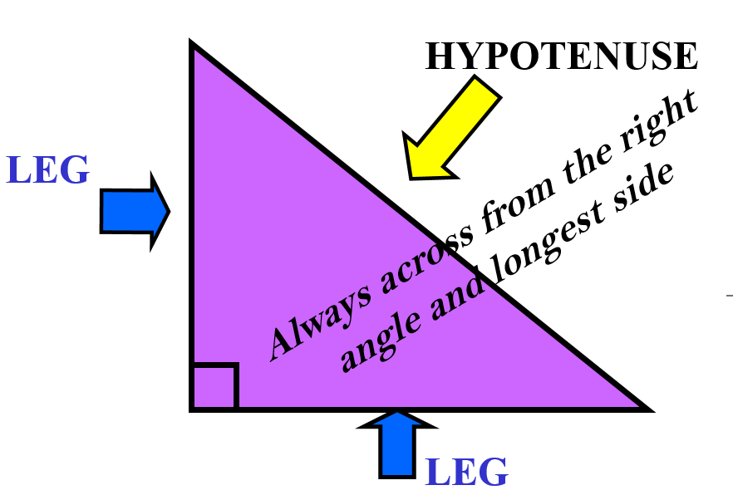

**Pythagorean Triples:** The sides of a right triangle that are integers and satisfy the Pythagorean Theorem. If you multiply any of these by a constant, you will have another Pythagorean Triple.

|  |  |  |  |  |
| --- | --- | --- | --- | --- |
| ***a*** | ***b*** | ***c*** | ***a*2 + *b2*** | ***c*2** |
| 3 | 4 | 5 | 9 + 16 = 25 | 25 |
| 5 | 12 | 13 | 25 + 144 = 169 | 169 |
| 7 | 24 | 25 | 49 + 576 = 625 | 625 |
| 8 | 15 | 17 | 64 + 225 = 289 | 289 |

Use the Pythagorean Theorem to find the length of each hypotenuse:

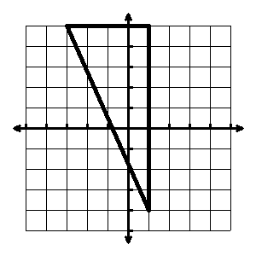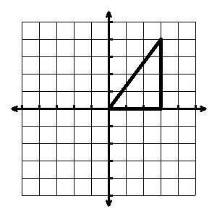



Find the length of the third side given two sides.

1. a = 16, b = 12
2. a = 3, c = 4
3. a = √204, b = 14
4. a = 6, c = 10

Use the Pythagorean Theorem to find the missing side:

1. 
2. 

Determine whether the given lengths are sides of a right triangle.

1. 12, 20, 16
2. 25, 24, 10
3. Find the distance from home plate to 2nd base.



**90 feet**

**90 feet**

**C =?**