**Module 3: Proportional Reasoning**

After completion of this unit, you will be able to…

**Learning Target #1: Proportional Reasoning with Ratios & Percents**

* Represent ratios using models (Tables, Graphs, Double Number Lines)
* Use models to determine equivalent ratios
* Read and Interpret ratios from multiple representations
* Calculate unit rates and use them to interpret problems
* Explain the similarities and differences between percents, fractions, and decimals
* Convert between fractions, decimals, and percents
* Use mental math to calculate percents
* Determine the part, whole, or percent of a number
* Apply percents to real world problems (tax, tip, discounts)

**Day 1:** **Ratios & Equivalent Ratios**

**Standard(s):** Students will use ratios to solve real-world and mathematical problems.

**MFAPR1.** Students will explain equivalent ratios by using a variety of models. For example, tables of values, tape diagrams, bar models, double number line diagrams, and equations. (MGSE6.RP.3)

A **ratio** is a comparison of two nonnegative quantities that uses division. Ratios can compare part to part or part to whole relationships. Words that indicate ratio relationships are ______________________________________.

Consider the following scenario: *On the co-ed soccer team, there are four times as many boys on it as it has girls. We would say the ratio is 4:1.*



|  |  |  |  |
| --- | --- | --- | --- |
| **Part to Part Comparisons** | | **Part to Whole Comparisons** | |
|  |  |  |  |
|  |  |  |  |
|  |  |  |  |

What other ratios would show four times as many boys as girls?

Practice: Create a ratio to describe the following:

a. There are 2 basketballs for every soccer ball.

b. There are 3 blueberry muffins in a 6 pack of muffins.

c. Each bagel costs $0.45.

d. For every 3 boys at soccer camp, there are 2 girls.

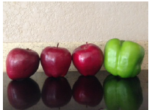e. Billy wanted to write a ratio of the number of apples to the number of peppers in his refrigerator. He wrote 1:3. Did Billy write the ratio correctly?

**Rates vs Ratios**

A **rate** is a ratio that compares two quantities that are measured in different units. If the rate is expressed as per 1 unit, it is considered a **unit rate**. When two ratios or rates are equivalent to each other, you can write them as a proportion.A **proportion** is an equation that states two ratios are equal.

|  |  |  |  |
| --- | --- | --- | --- |
| **Ratio**  2 red rose: 5 white roses | **Rate**  90 miles: 2 hours | **Unit Rate**  45 miles: 1 hour | **Proportion** |

Determine if the following can best be described as a ratio, rate, or unit rate:

a. 8 sugar cookies to 3 chocolate chip cookies b. 45 feet per second

c. 6 inches for every 3 years d. 6 boys for every 4 girls

**Creating Equivalent Ratios by Scaling Up or Down**

When we want to create equivalent ratios, we can use the same method as creating equivalent fractions. This is called scaling up or scaling down. Use the scaling up or scaling down method to determine the unknown quantity.

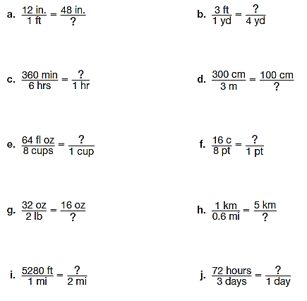

**Creating Equivalent Ratios Using Tables**

We can also use tables to determine equivalent ratios. Using the table below, show two calculations for the ratio of 150 lbs on Earth to 25 lbs on the moon.

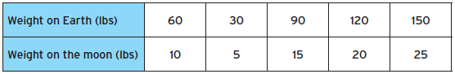

Each table represents a series of equivalent ratios. Complete each table showing how you calculated each number.

a.



b.

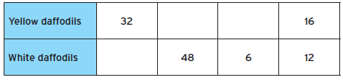

c.

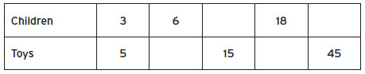

**Day 2:** **Unit Rates and Their Graphs**

**Standard(s):** MFAPR3. Students will graph proportional relationships.

a. Interpret unit rates as slopes of graphs. (MGSE8.EE.5)

b. Use similar triangles to explain why the slope m is the same between any two distinct points on a non-vertical line in the coordinate plane. (MGSE8.EE.6)

c. Compare two different proportional relationships represented in different ways. For example, compare a distance-time graph to a distance-time equation to determine which of two moving objects has greater speed. (MGSE8.EE.5)

**Unit Rates**

A **unit rate** is a comparison of two quantities in which the denominator has a value of one unit. To calculate a unit rate, just divide the numerator by the denominator. Unit rates are helpful in real life for determining the best buy, most miles per gallon, the fastest car, cellphone, etc., and many other uses. Take a look at the following example:

*A car dealership advertised the following rates on gal mileage for three new cars:*

*The Avalon can travel 480 miles on 10 gallons of gas.*

*The Compass can travel 400 miles on 8 gallons of gas.*

*The Patriot can travel 360 miles on 9 gallons of gas.*

Which car gets the best gas mileage? Change each ratio to a unit rate to help make your decision.

Practice: Using unit rates, determine the best buy.

a.

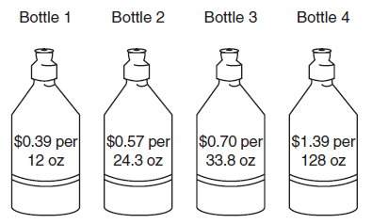

b.

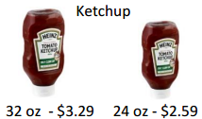

Unit rates are also helpful for calculating multiple numbers of an item (like when you are at the grocery store).

a. If a pound of bananas costs $0.53 a pound, how much are 4 pounds of bananas?

b. If a box of Cheerios costs $2.99, how much are 3 boxes of Cheerios?

c. If milk costs $2.59 a gallon, how much will 7 gallons cost?

**Problem Solving with Unit Rates**

a. Anne is painting her house light blue. To make the color she wants, she must add 3 cans of white paint to every 2 cans of blue paint. How many cans of white paint will she need to mix with 6 cans of blue?

b. Ryan is making a fruit drink. The directions say to mix 5 cups of water with 2 scoops of powdered fruit mix. How many cups of water should he use with 9 scoops of fruit mix?

c. A publishing company is looking for new employees who can type at least 45 words per minute. Jessie can type 704 words in 16 minutes. Does she type fast enough to qualify for the job?

**Using Unit Rates on a Graph**

Claire & Kate entered a cup stacking contest so they have been practicing. Below is a graph of their progress.

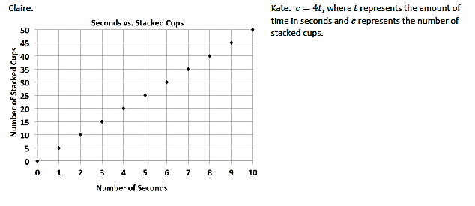

a. At what rate does each girl stack her cups during the practice session?

b. Kate notices she is not stacking her cups fast enough. What would Kate’s equation look like if she wanted to stack cups faster than Claire?

Emilio was to buy a new motorcycle. He wants to base his decision off the gas efficiency for each motorcycle. Which motorcycle is more gas efficient?

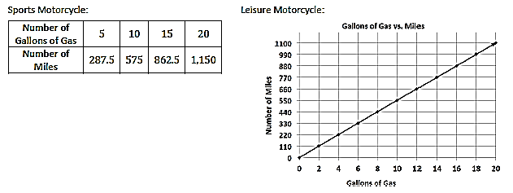

**When viewing a unit rate on a graph, you are essentially looking at the ______________ of the line!!**



Practice: Calculate the slope (unit rate) of each graph:

a. b.

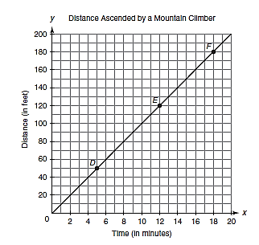 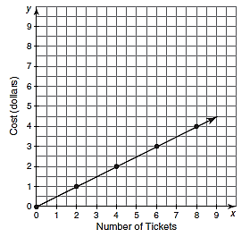

c. d.

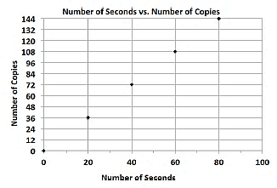 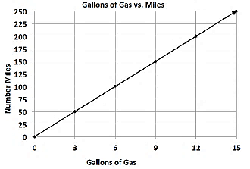

**Day 3:** **Proportions**

**Standard(s):** MFAPR2. Students will recognize and represent proportional relationships between quantities.

a. Relate proportionality to fraction equivalence and division. For example, $\frac{3}{6}$ is equal to $\frac{4}{8}$ because both yield a quotient of ½ and, in both cases, the denominator is double the value of the numerator. (MGSE4.NF.1)

b. Understand real-world rate/ratio/percent problems by finding the whole given a part and find a part given the whole. (MGSE6.RP.1,2,3; MGSE7.RP.1,2)

c. Use proportional relationships to solve multistep ratio and percent problems. (MGSE7.RP.2,3)

Review: A **proportion** is two ratios or fractions that are equal. A proportion allows you to create equivalent ratios using algebra. In order to solve proportions, you need to be able to solve a one-step equation.

Solve the following equations:

a. 3x = 9 b. 12x = 60 c. 2x = 10 d. 4x = 14

**Creating Equivalent Ratios Using Proportions**

When creating proportions, you can set up your proportions several ways. The key to creating them is to always match up corresponding parts or wholes. Look at the following scenario:

*In a Valentine’s Day bouquet, 2 out of every 5 roses are pink. If there are 6 pink roses, how many total roses are in the bouquet?*

Practice: Solve each problem by using a proportion.

a. Rita made 12 pairs of earrings in 2 hours. How many pairs of earrings could she make in 3 hours?

b. Perry earned $96 shoveling snow from 8 driveways. How much would Perry have earned if he had shoveled 10 driveways?

c. Marlene is planning a trip. She knows that her car gets 38 miles to the gallon on the highway. If her trip is going to be 274 miles and one gallon of gas is $2.30, how much should she expect to pay for gas?

**Multi-Step with Proportions**

a. For every 3 boys at soccer camp, there are 2 girls. If there are 20 children at soccer camp, how many are girls?

b. It takes Ryan about 8 minutes to type a 500-word document. How long will it take him to type a 12-page essay with 275 words per page?

c. Josie took a long multiple-choice test. The ratio of the number of problems she got incorrect to the number of problems she got correct was 2:9. If Josie missed 8 questions, how many did she get correct? How many questions were there total?

d. Sammy and David were selling water bottles to raise money for new football uniforms. Sammy sold 5 water bottles for every 3 water bottles David sold. Together, they sold 160 water bottles. How many did each boy sell?

e. The student faculty ratio at a small college is 17:3. The total number of students and faculty is 740. How many faculty and students are there at the college?

**Day 4:** **Introduction to Percents**

**Standard(s):** MFAPR2. Students will recognize and represent proportional relationships between quantities.

b. Understand real-world rate/ratio/percent problems by finding the whole given a part and find a part given the whole. (MGSE6.RP.1,2,3; MGSE7.RP.1,2)

c. Use proportional relationships to solve multistep ratio and percent problems. (MGSE7.RP.2,3)

Robb’s Fruit Farm consists of 100 acres on which three different types of apples grow. On 25 acres, the farm grows Honeycrisp apples. McIntosh apples grow on 30% of the farm. The remainder of the farm grows Fuji apples. Shade in the grid below to represent the portion of the farm each type of apple occupies.



|  |  |  |  |  |
| --- | --- | --- | --- | --- |
| **Type** | **Color** | **Fraction** | **Decimal** | **Percent** |
| Honeycrisp |  |  |  |  |
| McIntosh |  |  |  |  |
| Fuji |  |  |  |  |

Percents, fractions, and decimals can be used interchangeably. Percents are fractions that are out of 100. Percent is also another name for hundredths. The percent symbol “%” means out of 100. Percents are also considered ratios.

**Percents**

35% means 35 out of 100.

35% as a fraction is.

35% as a decimal is 0.35.

35% as a ratio is 35 to 100 or 35:100.

**Converting Between Decimals, Percents, & Fractions**

Percents to Decimals:

a. 13% b. 6% c. 90% d. 125%

Decimals to Percents:

a. 0.4 b. 0.32 c. 0.8427 d. 3.26

Fractions to Percents:

a.  b.  c.  d. 

**Graphic Organizer for Converting Between Percents, Decimals, & Fractions**

|  |  |  |  |
| --- | --- | --- | --- |
|  | **Fraction** | **Decimal** | **Percent** |
| **Percent** | Write the percent as a fraction with a denominator of 100. | Move the decimal point two places to the left and remove the % sign. |  |
| **Fraction** |  | Divide the numerator by the denominator. | Use division to write the fraction as a decimal, and then convert to a percent (Move decimal two points to the right) |
| **Decimal** | Write the decimal as a fraction with a denominator of 10, 100, or 1000. |  | Move the decimal point two places to the right and add the % sign. |

**Calculating Percents of a Number with Common Percents**

Discover: Use your calculator to determine the percent of each number:

a. 1% of 28 = ________ g. 10% of 28 = ________

b. 1% of 234 = ________ h. 10% of 234 = ________

c. 1% of 0.85 = ________ i. 10% of 0.85 = ________

d. 1% of 5.86 = ________ j. 10% of 5.86 = ________

e. 1% of 56.79 = ________ k. 10% of 56.79 = ________

f. 1% equals the decimal ______ l. 10% equals the decimal _______

Calculating 10% of a Number

* ______________________________
* ______________________________

Calculating 1% of a Number

* ______________________________
* ______________________________

Practice: Calculate the following percents:

a. 1% of 90 = ________ b. 1% of 75 = ________ c. 1% of 200 =________

d. 10% of 90 = _________ e. 10% of 75 = _________ f. 10% of 200 = _________

There are certain percents, called **benchmark percents that** are used commonly in real life. They are 1%, 5%, 10%, 25%, 50%, and 100%. State each relationship below:

a. How is 50% related to 100%? d. How is 5% related to 10%?

b. How is 25% related to 100%? e. How is 1% related to 10%?

c. How is 10% related to 100% 50 f. How is 25% related to 50%?

Practice; Try calculating the following percents mentally.

|  |  |  |  |  |  |
| --- | --- | --- | --- | --- | --- |
| **Number** | **50%** | **10%** | **1%** | **5%** | **25%** |
| **300** |  |  |  |  |  |
| **50** |  |  |  |  |  |
| **400** |  |  |  |  |  |
| **16** |  |  |  |  |  |

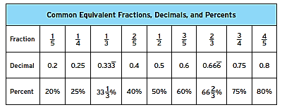

**Day 5: Percent Problems**

**Standard(s):** MFAPR2. Students will recognize and represent proportional relationships between quantities.

b. Understand real-world rate/ratio/percent problems by finding the whole given a part and find a part given the whole. (MGSE6.RP.1,2,3; MGSE7.RP.1,2)

c. Use proportional relationships to solve multistep ratio and percent problems. (MGSE7.RP.2,3)

**Determining Parts, Wholes, & Percents**

Percent problems involve three parts – the whole, the part, and the percent. As long as you know two out of the three quantities, you can determine the third. You can use the percent proportion to find the third quantity.

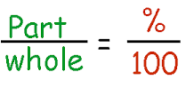

Practice: Calculate the missing quantity using either double number lines or the percent proportion.

a. 25% of 48 is what number? b. 12 is 20% of what number?

c. 90 is 75% of what number? d. 42 is 30% of what number?

e. If Jackson paid $450 for a laptop that was 75% of the original price, what was the original price?

f. Eric once had 240 downloaded songs in his collection. He deleted some and now has 180. What percent of his original collection did he keep?

**Percent Word Problems - Tax**

The tax rate in your county is 7% of the subtotal, which is then added on to determine the final cost. Suppose you buy an item that costs $18.00. What will be your total cost?

**Percent Word Problems - Tips**

You and your friend go to your favorite restaurant, The Cheesecake Factory, this past weekend. It is customary that for good service you tip your waiter 15% of the bill and 20% for exceptional service. Your bill, before tips, was $45.00. You had good, not exceptional service. What will be your total bill?

**Percent Word Problems - Discounts**

Your favorite brand of shoes, Chacos, is having a big sale – 25% off all shoes. The shoes you really want are currently $105.00, but they will be included in the sale. How much are the shoes you want now?

Error Analysis: Explain what Katie did wrong and what the correct answer should be:

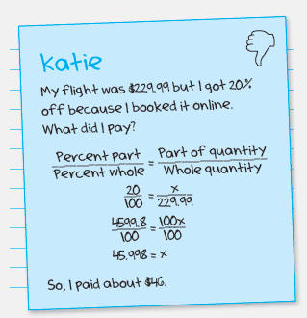

a. Sandra got 4 problems wrong on a test of 36 questions. What percent of the questions did he get correct?

b. Games that usually sell for $36.40 were on sale for $27.30. What percent off are they?

c. Tahjama and Viva are shopping for new shoes. They notice a flyer that says 40% off the sales tag price of all shoes. Tahjama finds a pair of shoes she likes but there is no sticker that gives the final sale price of the shoes. She knows that the original price is $120 and the original sale price is 25% off. Tahjama thinks she can add the two sale percents together (25% + 40% = 65%) whereas Viva disagrees. Who is correct and what is the final price of the shoes?

d. You need a graphing calculator for this class. The current price of the TI-84 Color calculators are regularly $120. Target, Staples, and Office Max are offering different sales on the TI-84 and you decide you want to save your parents as much money as possible. Which of the following offers will result in buying the calculator for the least amount of money?

* Target has the price of the graphing calculator down 30%, but if you show your student id, you receive an additional 25% off the original price.
* Staples has the price of the calculator marked down 25%, but if you come in between 1 pm and 3 pm, you get an additional 30% off the sale price.
* Office Max has the price of the graphing calculator marked down 50%.

Which store has the best priced calculator and how much is the calculator at each store?