**Module 1: Number Sense and Quantity**

After completion of this unit, you will be able to…

**Learning Target #1: Operations with Integers & Decimals**

* Add, subtract, multiply, and divide integers using a variety of strategies (number lines, counters, Mental Math)
* Compare integers
* Round and Compare Decimals
* Multiply and Divide by Powers of 10
* Apply Operations of integers & Decimals using real world applications

**Learning Target #2: Operations with Fractions**

* Add, Subtract, Multiply, and Divide Fractions using Models and Algorithms
* Simplify fractions
* Estimate fractions as Decimals and on a Number line
* Convert between mixed and improper fractions
* Compare fractions, decimals, and integers

**Learning Target #3: Operations with Radicals**

* Estimate Square Roots

**Day 1:** **Adding & Subtracting Integers**

**Standard(s):** **MFANSQ2.** Students will conceptualize positive and negative numbers (including decimals and fractions).

1. Explain the meaning of zero. **(MGSE6.NS.5)**
2. b. Represent numbers on a number line. **(MGSE6.NS.5,6)**
3. Explain meanings of real numbers in a real-world context. **(MGSE6.NS.5)**

The set of whole numbers and their opposites, including zero, are called **integers.**

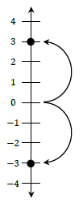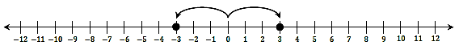

1. What is the relationship between -3 and 3? How far away are both -3 and 3 from zero?

2. On a horizontal number line, where are negative values located?

3. On a vertical number line, where are positive values located?

4. Circle the larger number:

1. -5 or -9 2. -3 or -1 3. -45 or -48 4. -123 or -120

5. Use the number line below to answer the following questions:



a. If zero is located at c, what are the values of a, b, & d? a = ______, b = ______, d = ______

b. If b is equal to -24, what are the values of a, c, & d? a = ______, c = ______, d = ______

**Absolute Value** is the distance from zero. We use | | when expressing numbers that we want the absolute value of. Name the absolute value of the following numbers:

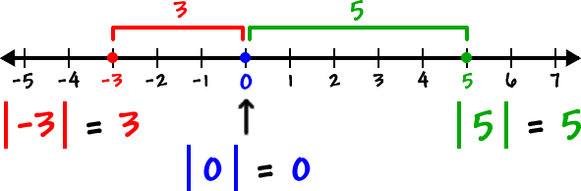

a. |4| = _______ b. |-6|=______

c. |-24| = ______ d. |0| = _____

**Modeling Integer Addition with Number Lines**

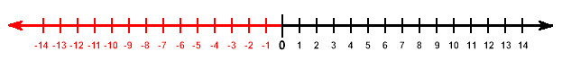

Using the number line, find the sum of the following problems:

a. 4 + 1 = _____________ b. -4 + -5 = _____________ c. -4 + 6 = _____________

d. 2 + -8 = _____________ e. -1 + -7 = _____________ f. -4 + 4 = _____________

**Think About it - Practice:**

Analyze the following addition problems and determine if the sum of the integers will be positive, negative, or zero. You may use the number line to help you if needed.

a. 5 + 2 = _____________ b. -4 + -3 = _____________ c. -3 + 6 = _____________

d. 4 + -8 = _____________ e. -1 + -3 = _____________ f. -5 + 5 = _____________

g. -7 + 4 = _____________ h. 9 + -2 = _____________ i. -3 + 8 = _____________

1. If you add two positive numbers, your sum will always be _____________________________________

2. If you add two negative numbers, your sum will always be ____________________________________

3. How do you determine if your sum will be positive or negative when adding a positve and negative integer together?

4. When will your sum equal zero?

**Modeling Integer Subtraction with Counters and Number Lines**

When subtracting integers, you need to understand the meaning of subtracting integers:

Subtraction Means

Take Away Add the Opposite

Let’s use counters to explore the two meanings of subtraction:

|  |  |
| --- | --- |
| **“Take Away”** | **“Add the Opposite”** |
| 6 – 4 = _____ | 6 – 4 = _____ |
| -6 – (-4) = _____ | -6 – (-4) = _____ |
| 6 – (-4) = _____ | 6 – (-4) = _____ |
| -6 – 4 = _____ | -6 – 4 = _____ |

**Practice**

**Directions: Add or subtract the following problems. Use your number line or counters to assist you if necessary.**

a. 3 + -8 = ______ b. 5 – 3 = ______ c. 2 – 9 = ______

d. 8 + -2 = ______ e. 10 + -5 = ______ f. -8 + 8 = ______

g. 6 – (-2) = ______ h. -4 – 7 = ______ i. 3 + -7 = ______

j. 13 + -5 = ______ k. 11 – (-3) = ______ l. -12 + 7 = ______

m. 6 – (-7) = ______ l. -4 + 9 = ______ o. 2 + -6 = ______

**Directions: Determine the missing number to complete each addition or subtraction problem. Use a number line or counters if necessary.**

p. 8 + ______ = 6 q. -4 + ______ = 3 r. -10 + ______ = -2

s. -5 – ______= 2 t. 3 – ______ = -8 u. – 5 – ______= -12

v. 4 – ______= -3 w. -7 – ______ = -9 x. 2 + ______ = -3

**Day 2:** **Multiplying & Dividing Integers and Real-World Applications**

**Standard(s):** **MFANSQ2.** Students will conceptualize positive and negative numbers (including decimals and fractions).

**MFANSQ2.** c. Explain meanings of real numbers in a real-world context. **(MGSE6.NS.5)**

**MFANSQ4.** Students will apply and extend previous understanding of addition, subtraction, multiplication, and division.

**MFANSQ4.** d. Illustrate and explain calculations using models and line diagrams. **(MGSE7.NS.1,2)**

Remember, multiplication is ___________________________________________.

**Rules for Dividing Integers**

Positive ÷ positive = positive

Negative ÷ positive = negative

Positive ÷ negative = negative

Negative ÷ negative = positive

Where did these rules come from???

**Rules for Multiplying Integers**

Positive x positive = positive

Negative x positive = negative

Positive x Negative = negative

Negative x negative = positive

Where did these rules come from???

|  |  |  |  |
| --- | --- | --- | --- |
| **Expression** | **Description** | **Addition Sentence** | **Product** |
| 3 x 4 |  |  |  |
| 3 x -4 |  |  |  |
| -3 x 4 |  |  |  |
| -3 x -4 |  |  |  |

Practice: Answer the following questions regarding multiplication.

1. Determine the single digit integers that make each number sentence true:

a. _____ x _____ = -25 b. _____ x _____ = 18 c. _____ x 4 = 16

2. Determine the product of the following expressions:

a. -3 x 2 x -4 = _____ b. -3 x -2 x -4 = _____ c. 3 x -2 x 4 = _____

d. -3 x -2 x 4 = _____ e. 3 x 2 x -4 = _____ f. -3 x 2 x 4 = _____

g. If the number of integers that are negative is an odd number, the sign of the product will be ______________.

h. If the number of integers that are negative is an even number, the sign of the product will be ______________.

3. Determine the sign of each product and how you know:

a. the product of four negative integers:

b. the product of seven negative integers:

c. the product of three positive numbers and nine negative numbers:

Critical Thinking: Complete the table by writing the sign (+, -, or +/-) to describe the sum, difference, product, or quotient. Then given an example in each box.

|  |  |  |  |  |
| --- | --- | --- | --- | --- |
| **Description of Integers** | **Addition**  **(Sum)** | **Subtraction**  **(Difference)** | **Multiplication**  **(Product)** | **Division**  **(Quotient)** |
| Two positive integers |  |  |  |  |
| Two negative integers |  |  |  |  |
| One positive & one negative integer |  |  |  |  |

**Real World Applications of Integers**

**Scenario #1:** For Tim’s 15th birthday, he received $150 in cash from his parents. His dad took him to the bank to open a savings account. Tim gave the cash to the banker to deposit into the account. The banker credited Tim’s new account $150 and gave Tim a receipt. One week later Tim deposited another $25 that he had earned as allowance. The next month, Tim’s dad gave him permission to withdraw $35 to buy a new video game. Tim’s dad explained that the bank would charge a $5 fee for each withdrawal from the savings account and that each withdrawal and charge results in a debit to the account. Complete the table below by documenting each action Tim took with his bank account. How much money does Tim have remaining in his savings account?

|  |  |  |
| --- | --- | --- |
| **Action** | **Integer** | **Balance** |
| Opened Bank Account |  |  |
|  |  |  |
|  |  |  |
|  |  |  |
|  |  |  |

**Scenario #2:** The picture below shows three different people participating in activities at three different elevations. What do you think the word elevation means?

Represent each description with an integer:

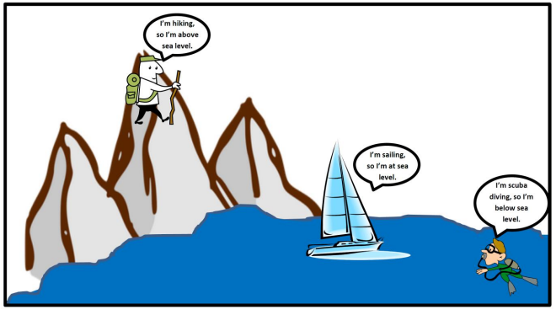

a. The scuba diver is 30 feet below sea level. ______

b. The sailor is at sea level. ____________

c. The hiker is 10,560 feet above sea level. _________

**Scenario #3:** An office building in downtown Atlanta has 20 floors above ground and 5 floors below ground for parking. Hunter parks on the third floor below ground and works on the 25th floor. Julia works on the top floor and parks on the lowest floor. Andrew works on the 15th floor but parks on whatever floor he can.

1. Let’s look at a day of traveling for **Hunter**:

a. Hunter decides to go to lunch with Andrew, but needs to go to his car first

because he forgot his wallet. How many floors does Hunter go down to get

to his car? Explain your reasoning.

b. After Hunter gets his wallet, he goes up to Andrew’s office. How many floors

does he go up to get to Andrew’s office? Explain your reasoning.

c. If Hunter did not go to his car to get his wallet, how many floors would he

have to go up or down to get to Andrew’s office? Explain your reasoning.

d. Andrew and Hunter go to lunch (which requires going to the 1st floor and

across the street) and then Hunter returns to his office. How many floors in

total did Hunter travel by the time he got back to his office? Explain your

reasoning.

**Practice**

1. Write an integer to describe each situation:

a. A company loses $345,000 in 2016. _____________

b. You earned $25 for dog sitting. _____________

c. Jacob owes his dad $5. _____________

d. The temperature at the sun’s surface is 5,500˚C. _____________

e. The temperature outside is 4 degrees below zero. _____________

f. A football player lost 10 yards when tackled. _____________

g. Jose dove 25 feet into the water. _____________

h. 14,000 feet above sea level. _____________

i. A debit of $40. _____________

2. Describe a situation that can be modeled by the integer -15. Explain what zero represents in the situation.

3. Which statement is written correctly?

a. The depth of the submarine is -800 feet below sea level.

b. The depth of the submarine is 800 feet below sea level.

4. Write each word under the appropriate column, “Positive Number” or “Negative Number.

Gain Loss Deposit Credit

Debit Charge Withdraw Owe

Below Zero Above Ground Receive Below Sea Level

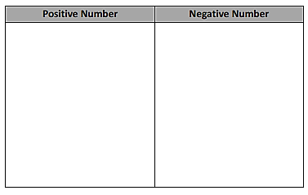

5. Can a temperature of -9 degrees be described as “Negative nine degrees below zero?” Why or why not?

**Day 3:** **Place Value & Multiplying and Dividing by Powers of 10**

**Standard(s):** **MFANSQ1. C.** Explain patterns in the placement of decimal points when multiplying or dividing by powers of ten. **(MGSE5.NBT.2**)

**Decimals** are one of the ways to show _________________. A **decimal** is a number that is written in a system based on ______________________________________. The decimal separates the whole amount from the decimal part of a number.

|  |  |  |  |  |  |  |  |
| --- | --- | --- | --- | --- | --- | --- | --- |
| **Thousands** | **Hundreds** | **Tens** | **Ones** | **Decimal Point** | **Tenths** | **Hundredths** | **Thousandths** |
|  |  |  |  |  |  |  |  |
| When I **multiply by factors of 10**, the decimal moves _____________ | | | | | | | |
| 1000 | 100 | 10 | 1 | . | 0.1 | 0.01 | 0.001 |
| 1000 | 100 | 10 | 1 | . |  |  |  |
| When I **divide by factors of 10**, the decimal moves _____________ | | | | | | | |

Practice: Multiply the following numbers mentally:

a. 1 x 10 = _________ b. 3 x 10 = _________ c. 40 x 10 = _________ d. 67 x 10 =_________

e. 5 x 100 =_________ f. 34 x 100 = _________ g. 670 x 100 = _________ h. 781 x 10 = _________

i. 0.4 x 10 = _________ j. 8.2 x 10 = _________ k. 9.8 x 100 = _________ l. 17.8 x 10 = _________

m. 45.6 x 100 = _________ n. 176.3 x 10 = _________ o. 32.5 x 1000 = _________ p. 0.2 x 10 = _________

Describe a rule for multiplying by a factor of 10:

**Practice:** Divide the following numbers mentally:

a. 1 ÷ 10 = _________ b. 3 ÷ 10 = _________ c. 40 ÷ 10 = _________ d. 67 x 10 =_________

e. 5 ÷ 100 =_________ f. 34 ÷ 100 = _________ g. 670 ÷ 100 = _________ h. 781 x 10 = _________

i. 0.4 ÷ 10 = _________ j. 8.2 ÷ 10 = _________ k. 9.8 ÷ 100 = _________ l. 17.8 ÷ 10 = _________

m. 45.6 ÷ 100 = _________ n. 176.3 ÷ 10 = _________ o. 32.5 ÷ 1000 = _________ p. 0.2 ÷ 10 = _________

Describe a rule for dividing by a factor of 10:

**Explore More Patterns with Powers of 10**

**Directions:** Multiply/divide the following numbers:

What did you notice?

1. a. 3 x 10 = __________ b. 3 ÷ 0.1 = __________

2. a. 456 ÷ 100 = __________ b. 456 x 0.01 = ________

3. a. 67 x 100 = ___________ b. 67 ÷ 0.01 = ___________

**Relationships between Multiplying & Dividing by Powers of 10**

Multiplying by 1000 = Dividing by _________

Multiplying by 100 = Dividing by _________

Multiplying by 10 = Dividing by _________

Multiplying by 0.1 = Dividing by _________

Multiplying by 0.01 = Dividing by _________

Multiplying by 0.001 = Dividing by _________

4. a. 872 x 10 = ___________ b. 872 ÷ 0.1 = ___________

5. a. 34 ÷ 10 = ___________ b. 34 x 0.1 = ___________

6. a. 386 ÷ 100 = ___________ b. 386 x 0.01 = __________

**Explore Even More Patterns with Powers of 10!**

Directions: Fill in the missing blanks and then describe the rule(s):

a. 0.03 0.3 _____________ 30 _____________ _____________ Rule: _______________________

b. _____________ 7.5 750 75,000 _____________ Rule: _______________________

c. _____________ 9,430 _____________ 94.3 9.43 _____________ Rule: _______________________

**Day 4:** **Plotting, Comparing, Ordering, & Rounding, Decimals & Integers**

**Standard(s):** **MFANSQ1. C.** Explain patterns in the placement of decimal points when multiplying or dividing by powers of ten. **MFANSQ1.** d. Compare fractions and decimals to the thousandths place. For decimals, use place value.

When you write a decimal, you are writing a representation of a fraction with denominators of 10, 100, and 1000. The place value of the number corresponds to the denominator of the equivalent fraction. Each position of a number in a decimal is 10 times the value of the position to its right.

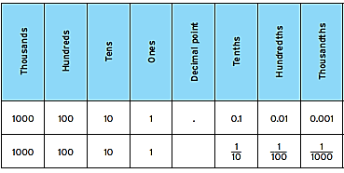

When we expand decimals, we see the fractions and whole numbers in relation to each place value. Expand the decimals and write their fraction equivalency:

a. 3481.52 =

b. 49.653 =

c. 0.417 =

d. Five dimes =

e. 8 pennies =

**Plotting Decimals on a Number Line**

a. Plot the decimals from 0 to 1.



b. Plot the decimals from 0.6 to 0.7



c. Plot the decimals from 1.45 to 1.55



d. Plot the decimals from -1 to 0.



e. Plot the decimals from -1.3 to -1.2.



f. Plot the following numbers on the number line below.

**0.45 1.78 2.95 2.6 1.3 1.75 0.16 0.6 2 2.91**



g. Find the midpoint between the following numbers:

a. 0 _________ 10 b. 3 _________ 4 c. 0.2 _________ 0.3

d. 0.03 _________ 0.04 e. 0.13 _________ 0.14 f. 7.8 _________ 7.9

g. 1.26 _________ 1.27 h. 1.59 _________ 1.60 i. 3.99 _________ 4

**Comparing and Ordering Decimals**

**Inequality Signs**

< _____________

> _____________

= ______________

Determine if the numbers are <, >, or = to each other.

a. 0.2 ______ 0.25

b. 0.3 ______ 0.03

c. 0.3 ______ 0.30

d. 0.32 _______ 0.3

e. 0.999 _______ 1.0

f. 0.6 ________ 0.09

g. 3.48 ________ 3.4

h. -1.6 ________ -1.45

Real World Scenario: Coach Hubinger asked Taylor to keep track of the times in the 400-meter dash. Taylor recorded the times in the table as shown. List the runner’s times in order from fastest to slowest. Who won the race?

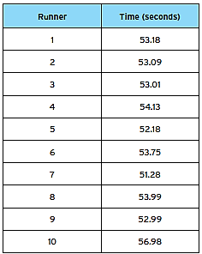 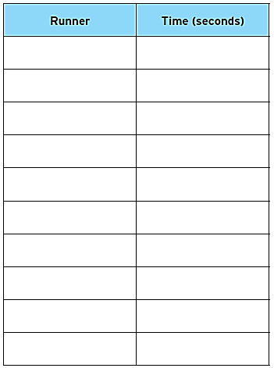

a. How did you decide which decimal was the fastest? How did you determine the person with the next fastest time?

**Rounding Decimals**

Consider the decimal and answer the following questions: **13.179**

a. Is this decimal closer to 10 or 20? ___________ Why? __________________________________________

b. Is this decimal closer to 13 or 14? ___________ Why? __________________________________________

c. Is this decimal closer to 13.1 or 13.2? ___________ Why? __________________________________________

d. Is this decimal closer to 13.17 or 13.18? ___________ Why? __________________________________________

**Practice:** Round the following numbers to the given place value in the table.

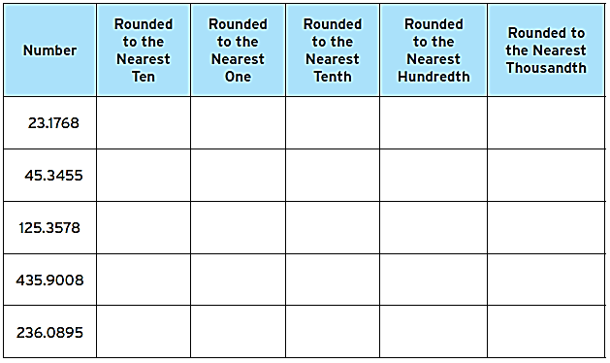

**Real World Scenario:** A trip from New York to Seattle is 2852.1 miles. A family wants to make the drive in 10 days, driving the same number of miles each day. About how many miles will they drive each day? Round your answer to the nearest mile.

Critical Thinking: A decimal has two digits to the right of its decimal point. If we round it to the nearest tenth, the result is 18.6.

a. What is the smallest number that would result it being rounded to 18.6?

b. What is the largest number that would result it being rounded to 18.6?

**Day 5:** **Fractions on a Number Line & Benchmark Fractions**

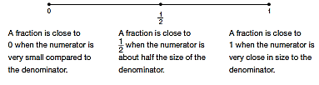

**Benchmark Fractions** are common fraction you can use to estimate the value of fractions. The most common benchmark fractions are 0, ½, and 1.

Observe: Complete the table below using the number lines you created.

|  |  |  |
| --- | --- | --- |
| **Benchmark Fraction** | **Using your number lines, list fractions that are close to the stated benchmark fraction.** | **What do you notice about the numerator & denominator?** |
| 0 |  |  |
| ½ |  |  |
| 1 |  |  |

Practice: Name the closest benchmark fraction for each fraction given.

a.  b.  c.  d.  e.  f.  g. 

**Practice: Fill in the missing numbers:**

a. Write the unknown numerator or denominator so that each fraction is close to but less than 1.

     

b. Write the unknown numerator or denominator so that each fraction is close to but more than ½.

     

c. Write the unknown numerator or denominator so that each fraction is close to but less than ½.

     

**Day 6**: **Comparing, Ordering, and Converting Fractions**

**Standard(s):** **MFANSQ1.** d. Compare fractions and decimals to the thousandths place. For fractions, use strategies other than cross multiplication. For example, locating the fractions on a number line or using benchmark fractions to reason about relative size. For decimals, use place value.

To compare fractions, you can use a variety of strategies, such as using benchmark fractions, creating equivalent fractions, and converting fractions to decimals.

**Method 1:** Using Benchmark Fractions

When using Benchmark Fractions, try to determine if your fractions are close to 0, little less than ½, little more than ½, or close to 1.

a.  b.  c.  d. 

**Method 2:** Creating Equivalent Fractions

* If you notice the denominators are the same, then you just need to compare the numerators.
* If you notice the numerators are the same, then you need to think about the size of the groups of the number in the denominator.
* If you notice that you could easily make an equivalent fraction with one of the fractions, then create equivalent fractions.
* You can also always draw a picture.

a.  b.  c.  d. 

e. f.  g. h. 

Who is Right???Read the following scenario and determine who is correct.

*Four students are designing a logo that involves patterns and solid colors. Nakida claims she has the greatest fractional part of plaid in her design while Sandy claims she has the greatest fractional part of plaid in her design. Who is correct and why?*

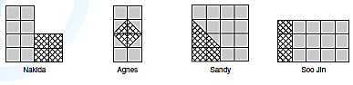

**Simplifying Fractions**

You know how to create equivalent fractions already. You understand that if two fractions are equivalent, they share a common factor. A fraction is in simplest terms if all common factors have been removed from the numerator and denominator. Can you work backwards to put a fraction in simplest form?

Method 1: Prime Factorization Method 2: GCF

 

Practice: Simplify each fraction using the method of your choice.

a.  b.  c.  d. 

**Improper Fractions and Mixed Numbers**

An **improper fraction**is a fraction where the numerator is bigger than the denominator. A **mixed number** is a fraction with a whole number part.

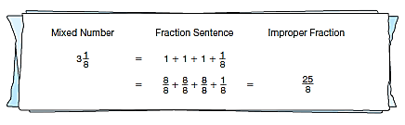

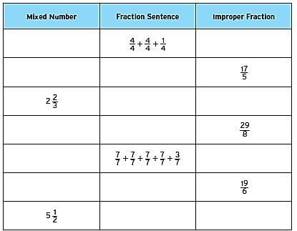

**Ordering Integers, Fractions, and Decimals**

When ordering integers, fraction, and decimals, it is helpful to use benchmark fractions and decimals, in addition to converting all your numbers so they are in the same form. Some fractions are easily convertible to decimals, some fractions are important fractions that can be memorized, and some fractions you will have to convert to decimals using a calculator. Let’s look at the three types:

|  |  |  |
| --- | --- | --- |
| **Decimal Fractions** | **Important Fractions** | **Fractions to use with a Calculator** |
| **Decimal Fractions** are fractions whose denominators are 10, 100, and 1000. Their decimal form is how you say the fraction properly.  =  =  =  =  = | Common fractions are fractions that occur frequently through math. The following list are common fractions that if you know their decimal equivalency, it can be extremely beneficial.  =  = =  =  =  = = = = | Fractions to determine with a calculator are essentially every other type of fraction. To enter them into your calculator, enter the numerator divided by the denominator.  =  =  =  = |

Practice: Order the following numbers in order from least to greatest:

a. 6.45, -0.67, , , -4, 3, 3.38, 

b. -2.6, -0.7, , , -2.34, , , 

c. , , , , , , 

**Day 7:** **Adding and Subtracting Fractions**

**Standard(s):** **MFANSQ4. b.** Find sums, differences, products, and quotients of all forms of rational numbers, stressing the conceptual understanding of these operations.

Review: Complete each equation to make the fractions equivalent.

a.  b.  c.  d. 

e.  f.  g.  h. 

Two or more fractions that have a **________________________________** are fractions whose denominator is the same. Fractions that have the same denominator make it really easy to add fractions.

**Adding & Subtracting Fractions**

Fractions can only be added or subtracting together if they have common denominators!



**Step 1**: Rewrite one or both of the fractions, using equivalent

fractions, so you can get a common denominator.

**Step 2**: Add or subtract the numerators while keeping the

denominators the same.

Practice: Add or subtract the following fractions.

a.  b.  c.  d. 

Think About It: What about adding and subtracting mixed numbers???

e.  f.  g.  h. 

Conclusion: When I add or subtract mixed numbers, I plan to _____________________________________________

___________________________________________________________________________________________________________

**Adding & Subtracting Word Problems**

1. Joe spends of his money on a jacket and of his money on a shirt. He spends the rest on a pair of pants. What fraction of his money does he use to buy the pants?

2. Madame Curie made some radium in her lab. She used kg of the radium in an experiment and had  kg left. How much radium did she have at first?

3. Sandy ate  of a candy bar. John ate  of it. How much more of the candy bar did John eat than Sandy?

**Day 8:** **Multiplying Fractions**

**Standard(s):** **MFANSQ4.** b. Find sums, differences, products, and quotients of all forms of rational numbers, stressing the conceptual understanding of these operations.

c. Interpret and solve contextual problems involving division of fractions by fractions.

***Scenario:*** *You are going to be buying extra-large rectangular pizzas to sell at the home football games. Each pizza will cost $24, but customers can buy part or all of a pizza.*

a. Gage bought of a pizza. How much pizza did he buy and how much did he pay?

b. Tyler bought of a pizza. How much pizza did he buy and how much did he pay?

c. Tyler bought of a pizza. How much pizza did he buy and how much did he pay?

d. What patterns did you notice when modeling multiplication of fractions?

e. Maddy noticed that when she multiplies two fractions, the product is less than each of the fractions multiplied. Jackson doesn’t think this is correct because he remembers from middle school that when you multiply two numbers, their product is supposed to be bigger. How can you help Jackson correct his thinking?

Describe how you multiply two fractions:

Practice: Multiply the following fractions. Make sure your fractions are simplified.

a.  b.  c.  d. 

e.  f.  g.  h. 

**Multiplication of Fractions within a Context**

a. b. c.

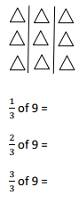 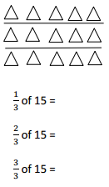 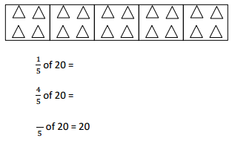

d. There are 32 students in a class. Of the class,  of the students bring their own lunches. How many students bring their lunch?

e. Jack collected 18 ten-dollar bills while selling tickets for a show. He gave  of the bills to the theater and kept the rest. How much money did he keep?

f. Ms. Phillips ordered 56 pizzas for a school fundraiser. Of the pizzas ordered, of them were pepperoni, 19 were cheese, and the rest were veggie pizzas. What fraction of the pizzas were veggie?

g. Terrence finished a word search in the time it took Frank. Charlotte finished the word search in  the time it took Terrence. Frank finished the word search in 32 minutes. How long did it take Charlotte to finish the word search?

**Day 9:** **Dividing Fractions**

**Standard(s):** **MFANSQ4.** b. Find sums, differences, products, and quotients of all forms of rational numbers, stressing the conceptual understanding of these operations.

c. Interpret and solve contextual problems involving division of fractions by fractions.

**Review:** What does it mean when you are asked what 8 ÷ 2 means? Draw a picture to represent 8 ÷ 2.

8 ÷ 2 means how many groups of _______________________ are in ___________________________?

**Dividing Fractions Using an Algorithm**

**Review:** Determine the reciprocals of the following fractions:

a.  b. 3 c.  d.  e.  f.  g. 0

**Explore:** To understand the reasoning behind dividing fractions, it is easiest to turn our division problem into a compound fraction. Dividing by a fraction is hard, but dividing by **one** is really easy. But how do we turn into one? By multiplying by its reciprocal!

a. 2 ÷  b. ÷ c. ÷

**Practice:** Divide the following fractions and then check your answer with your answers in problems d – h.

d.  ÷  e.  ÷ 

f.  ÷  g.  ÷ 

h.  ÷ 

How do you think you would divide mixed numbers when you consider how you divided the fractions on the previous page and calculated the reciprocal of the mixed numbers in the review section? Write down what you think:

**Practice:** Divide the following fractions.

i.  ÷  j.  ÷ 

**Division of Fractions within a Context**

a. You have 4 cups of lemonade. If each student receives cup, how many students are there? Solve your problem using one model AND an algorithm (to check your work).

b. One of the most beautiful hiking trails in the United States is Glacier Gorge in Rocky Mountains National Park. The hiking trail through Glacier Gorge is  miles round trip. Answer the following questions using one model AND an algorithm (to check your work).

1. If you need to rest every mile, how many rest stops will you need?

2. If you hike miles an hour, how many hours will the round trip take?

**Day 10:** **Estimating Square Roots**

**Standard(s):** **MFANSQ3.** a. Find an estimated decimal expansion of an irrational number locating the approximations on a number line. For example, for √2 show that √2 is between 1 and 2, then between 1.4 and 1.5, and explain how to continue this pattern in order to obtain better approximations.

What does it mean to **SQUARE** a number? __________________________________________________________________

List three number examples of you squaring a number:

**Square Root Table**

Complete the table below.

|  |  |  |  |  |  |  |  |  |  |  |
| --- | --- | --- | --- | --- | --- | --- | --- | --- | --- | --- |
| **1** | **2** | **3** | **4** | **5** | **6** | **7** | **8** | **9** | **10** | **x** |
|  |  |  |  |  |  |  |  |  |  |  |
|  |  |  |  |  |  |  |  |  |  |  |
|  |  |  |  |  |  |  |  |  |  |  |
|  |  |  |  |  |  |  |  |  |  |  |

Square each of the

following numbers.

Show what squaring a

number really means

**Perfect Squares**

Take the square root of

each of your perfect

squares.

**Square Roots**

**Perfect Squares** are the product of a number multiplied by itself (4 ∙ 4 = 16; 16 is the perfect square).

Think about the process we just performed: **Number → Squared It → Took Square Root → Same Number**

A root and an exponent are **inverses** of each other (they undo each other). Therefore, square roots and squaring a number are **inverses** or they undo each other, just like adding and subtracting undo each other.

Practice: Answer the following.

a.  b.  c.  d.  e. 

**Estimating Square Roots to the Nearest Whole Number**

The square root of most numbers is not an integer. How can we use our knowledge of square roots and perfect squares to estimate the value of a square root without using a calculator?

Using the number line below, square each of the following numbers and write their product underneath each number.



On the previous page, we ran into an issue because and  were not ____________________________.

Using my number line, I can see that  is between which two whole numbers? What about?

Practice: Tell which two square roots, followed by which two whole numbers the following square roots are between:

a. ________ << ________ b. ________ << ________ c. ________ << ________

________ << ________ ________ << ________ ________ << ________

Closer to _________ Closer to _________ Closer to _________

You were able to determine what two whole numbers each of the square roots were between, but how can we be even more accurate without a calculator?

**Estimating Square Roots More Accurately**

a. Let’s look at the, which was located between __________ & __________? Let’s put those two square roots on a number line.

b. Let’s look at the, which was located between __________ & __________? Let’s put those two square roots on a number line.

c. Let’s look at the, which was located between __________ & __________? Let’s put those two square roots on a number line.

**Practice:** Calculate the square root of each number using the number line method.

a. 

b. 

c. 